**Uganda Advanced Certificate of Education**

**APPLIED MATHEMATICS**

**P425/1**

2 Hours 30 Minutes

**Instructions:**

* *Answer all questions in section A and any five in section B.*

***SECTION A (40 MARKS)***

1. A particle moving in a straight line with a constant acceleration has an initial velocity of 18Kmh-1. After 4 seconds its velocity was 15ms-1. Calculate the distance covered by the particle in the fourth second. (5marks)

2. A particle of weight 50N is placed on a smooth plane inclined at $sin^{-1}\left(\frac{1}{2}\right)$ to the horizontal. Find the horizontal force, P, required to keep the body in equilibrium. (5marks)

3. After 2 seconds of projection, a particle projected form the top of a vertical cliff 6 metres high with speed Ums-1 at an angle of elevation θ to the horizontal, passes just above the top of a vertical pole post which is 4m high and 8m away from the base of the cliff.

i) Show that $tanθ{=2.2}$.

ii) find the value of U. (5marks)

4. A car of mass 400kg ascends up a slope of 5 in 14 with coefficient of friction being $\frac{1}{3}$, if the engine of the car is working at a constant rate of 40kw, find the acceleration of the car when it is travelling at a velocity of 20ms-1. (5marks)

5. To a cyclist riding due South at 12Kmh-1, a strong wind appears to come. From west. When he reduces his speed to 3Kmh-1, the wind appears to come from East. Find the true velocity of wind. (5marks)

6. Forces of 6N, 8N, 7N, 5N and 9N act on a rectangle ABCD where AB = 8cm and BC = 6cm in the directions AB, CD, DC, AD and DB respectively. Find the magnitude and direction of the resultant force. (5marks)

7. A particle of mass 2kg moves under the action of the force which depends on the time t, given by force $F = 24t^{2}\underbrace{i}+ \left(36t-16\right)\underbrace{j}$. Given that at t = 0 the particle is located at 3 $\underbrace{i}- \underbrace{j}$ and has a velocity $6\underbrace{i}+15\underbrace{j}$. Find the kinetic energy of the particles at t = 2. (5marks)

8. A particle projected from a point O at an angle of 50o above the horizontal passed through the point, P with position vector $70i+28j$. Find the

i) Initial velocity

ii) Time taken to reach P. (5marks)

**SECTION B (60 MARKS)**

9. The figure below shows a mass of 10kg placed on a smooth incline of inclination 60o attached to a mass of 3Kg placed on a rough horizontal table by means of an inelastic string passing over a smooth pulley and connected to a second mass of 2Kg on the table by means of another string. The coefficient friction of the table. is $\frac{1}{ 3}$.

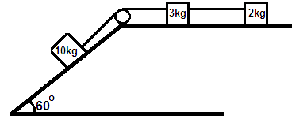

1. Find the acceleration of each mass
2. Find the tension in each string
3. Reaction on the pulley. (12mark)

10. A ball is projected from the top of a vertical cliff 36m high with speed 40ms-1 at an angle of elevation θ as shown..

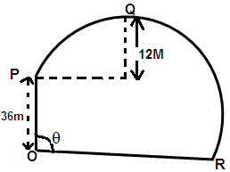

The ball passes horizontally through point Q which is 12m above the level of point P and hit the ground at point R. find the

1. Value of θ
2. Distance OR
3. Speed and direction of the ball as it hits point R.

11.

11. 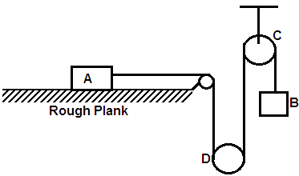

A particle A resting on a rough wooden plank (coefficient of friction µ) is connected to another particle B by a light inextensible string passing under a movable pulley D and over a fixed pulley C, as shown above. Particles A and particle B are each of mass M. the system is released from rest.

(a) show that the tension in the string is $\frac{1}{6}$ mg (3 + µ). (8marks)

b) If only B and D move, while A stays at limiting equilibrium, find the value of µ. (4marks)

12. A car of mass 800kg is towing a trailer of mass 150kg on a level road. The resistance to the car and the trailer amount to 7N per Kg of their mass.

a) Calculate the tension in the tow bar when the car and the trailer are travelling at a constant speed.

b) The car and the trailer now climbs a slope of an inclination of 1/20. If the frictional resistances are the same as before and the power of the engine is 50Kw, calculate

i) The maximum speed up the slope.

ii) The acceleration when the speed is 54Kmh-1. (12marks)

13. a) To a pilot of a plane flying at 180Kmh-1 on a bearing of S 30ow, the wind appears to blow from S40ow at 190Kmh-1. Find the true speed of the wind. (4marks)

b) Two birds, A and B are initially at points with position vectors (5i + 8j + 12k)m and (2i – 4j + 15k)m respectively. If they are respectively flying with constant velocities of (2i + j+K)ms-1 and (i +2j+2k)ms-1, find the

i) time at which they are closest together

ii) distance that then separates them. (8marks)

14. A particle is projected from the top of a tower of height 10m with a speed of 12ms-1. Find how far from the foot of the tower the particle hits the ground if.

i) it is fired horizontally.

ii) Fired at depression of 30o. (12marks)

15. a) A force F= $\left({4+t^{2} \atop 2t}\right)$ acts on a particle of mass 0.5kg from t=0 to t=2 seconds. Find,

i) Power developed when t=1

ii) Impulse of the force during the interval t = 0 to t = 2. (7mrks)

b) Two forces F1 and F2 have magnitudes $∝and β$ act in the directions. I – 2j and 4j + 3j respectively. Given that the resultant is F = 3i + 4j. find $∝and β$. (5marks)

**END**